Multiple choice section

Question 1 [8.2]

An angle of size 195° is called:

A reflex B obtuse C acute D straight

Question 2 [8.7]

Which of the following statements concerning quadrilaterals is true?

A The two interior opposite angles of a kite where unequal sides meet are never equal.

B Diagonally opposite angles in a parallelogram are unequal.

C A square is not a type of rhombus

D None of the above are true.

Question 3 [8.4]

This symbol ⊥ means that the two lines

A are parallel B form a straight angle

C are equal in length D are perpendicular

Question 4 [8.3]

Three angles make a revolution. The angles are 30°, 180° and x. The value of x is:

A 70° B 150° C 152° D 20°

Question 5 [8.7]

The quadrilateral shown is:

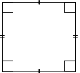

A a square B a parallelogram C a rhombus D All of the above

Question 6 [8.4]

The symbol || represents:

A parallel lines B perpendicular lines

C lines of equal lengths D a marked angle

Question 7 [8.5]

What is the name of a polygon with 13 sides?

A octagon B nonagon C decagon D none of the above

Question 8 [8.6]

The diagram shows a triangle that is:

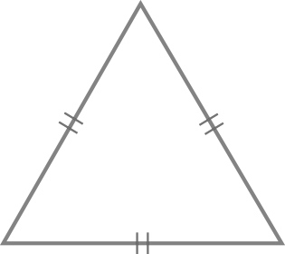

A scalene B acute-angled C equilateral D both B and C

Question 9 [8.3]

The size of angle x minus 20° is

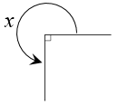

A 90° B 270° C 250° D 175°

Question 10 [8.3]

Angles x and y are vertically opposite angles. If y = 173°, x is equal to:

A 7° B 27° C 173° D 187°

Multiple-choice total marks: _____ / 10

Short answer section

Question 11 2 marks [8.2]

Describe the term supplementary angles. Use an example to help you explain.

Question 12 2 marks [8.1]

Use a protractor to measure the size of the following angles, correct to the nearest degree.

(a) 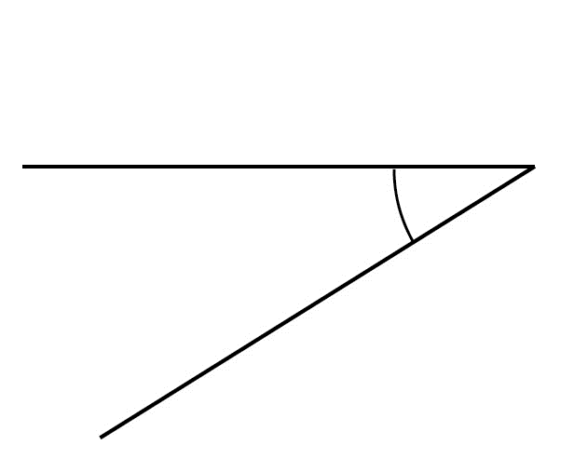(b) 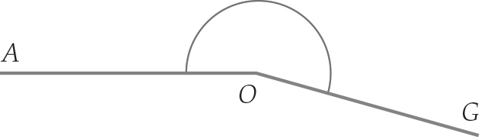

Question 13 2 marks [8.1]

Draw an angle of 170°.

Question 14 4 marks [8.2]

Use the diagram below to state:

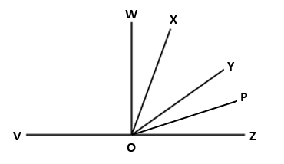

(a) name two obtuse angles, other than ∠*VOP* ____________________

(b) a right angle ____________________

(c) any one acute angle ____________________

Question 15 3 marks [8.3]

Find the size of the angle marked x, giving reasons.

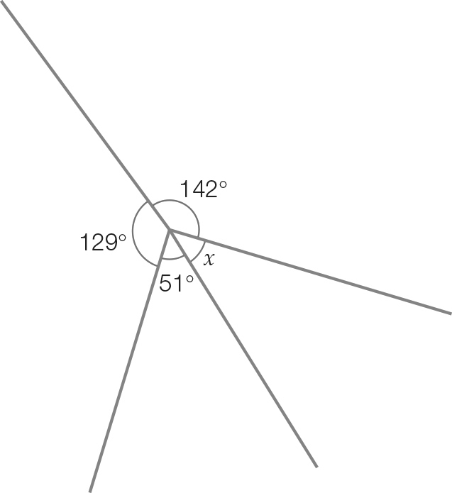

Question 16 1 marks [8.4]

On the following diagram, mark in an angle alternate to the one shown.

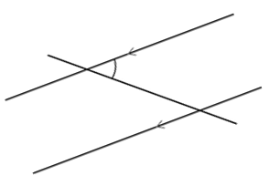

Question 17 2 marks [8.4]

Find the size of the angle marked x, giving reasons.

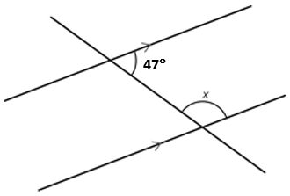

Question 18 3 marks [8.5]

Name the polygons in the pattern.

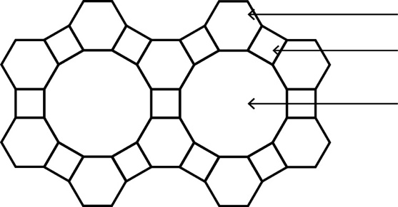

Question 19 4 marks [8.6]

Draw a diagram and then find the size of the missing angle in each of the following.

(a) A triangle with angles measuring 35° and 115°.

(b) An isosceles triangle with a non-base angle measuring 40°.

Question 20 2 marks [8.6]

Calculate the value of the exterior angle.

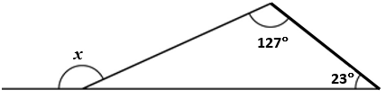

Question 21 2 marks [8.7]

Find the size of the angle marked x.

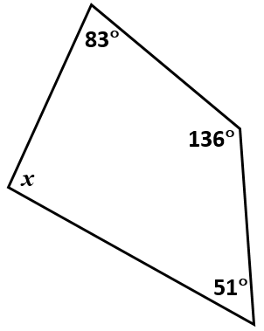

Question 22 2 marks [8.7]

A kite has a top angle measuring 136° and a bottom angle measuring 24°. Draw a diagram and find the size of the other two angles. Give reasons.

Question 23 4 marks [8.8]

Using only a compass, a ruler and a pencil, construct an angle of 120°. Leave all construction lines.

Question 24 4 marks [8.8]

Using only a compass, a ruler and a pencil, construct a pair of parallel lines.

Question 25 5 marks [8.7]

Fill in the tree map below using all the words in the following list:

kite, parallelogram, rectangle, right trapezium, trapezium.

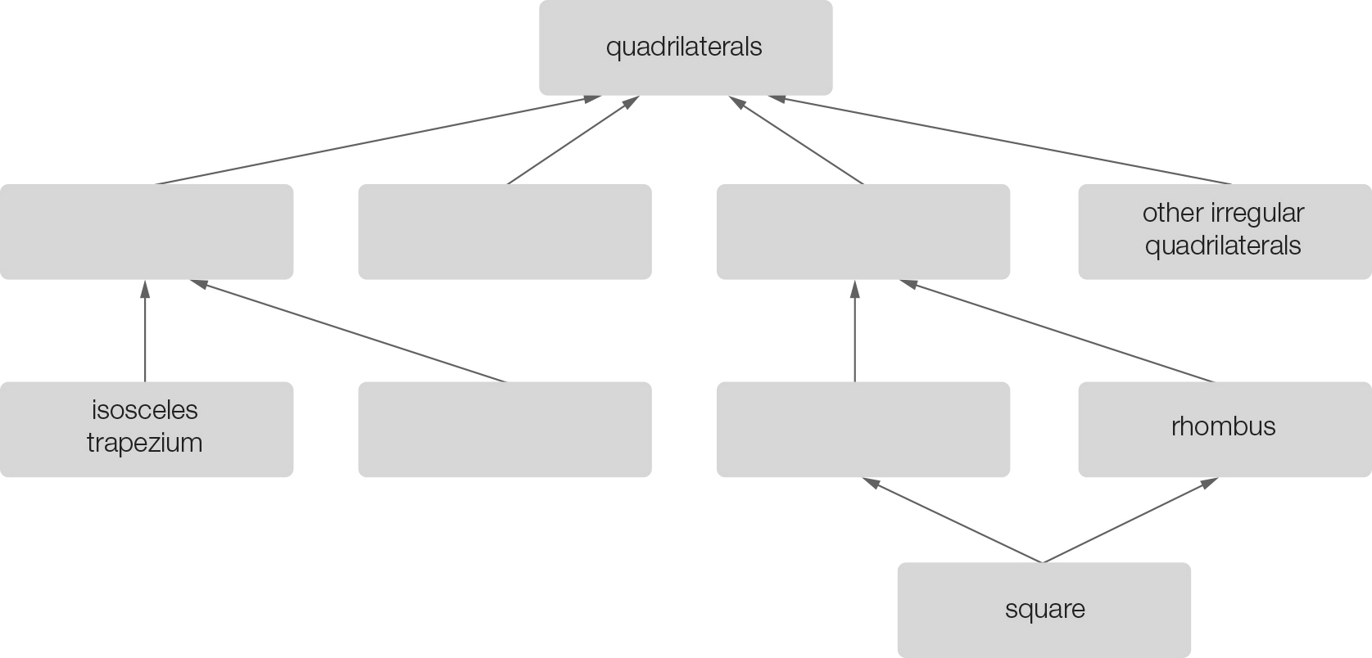

Short answer total:_______ /42

Extended answer section

Question 26 4 marks [8.3]

Find the size of the angle x, giving reasons.

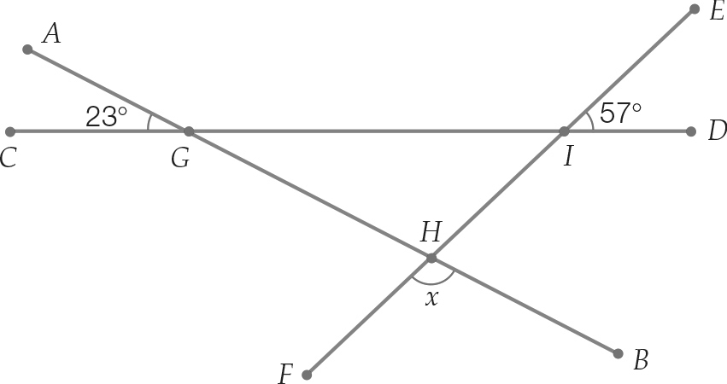

Question 27 3 marks [8.3]

Find the value of x.

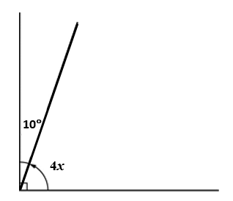

Question 28 4 marks [8.7]

Find the value of *y* in the diagram below.

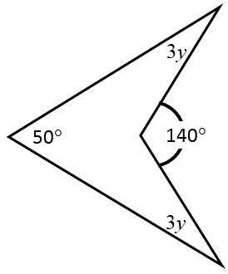

Extended answer total:_______ /11

TOTAL test marks: _______ / 63